  Practice and postal address | International Society of Schema Therapy  https://schematherapysociety.org/  ISST Case Conceptualization Form  Guidelines for translators

Updated 5th May 2023
The translations of the Case Conceptualization Form and associated materials must be formatted in the same way as the original English versions. It is recommended that you use the original English versions as a template for setting up your translation and replace the English on the form with your translation.
Managing the spacing
The translation you provide may take up more or less space on the page than the English original. When this happens you can edit the spacing to ensure that there is a smooth flow between the pages. This can be done in the following ways:
1 Using the spacing dialogue box on the Paragraph menu.  Click on the arrow on the right of “Paragraph” to access this menu.  This will open the dialogue box below. | 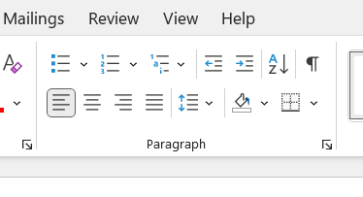

At the top you can correct the indentation of lines or paragraphs if they get out of alignment.  Below that you can alter the spacing between paragraphs by changing the value in the “Before” and “After” boxes.  You can also change the line spacing on the right.  You can also use this menu to see what the values are for indents and spacing on the English original | 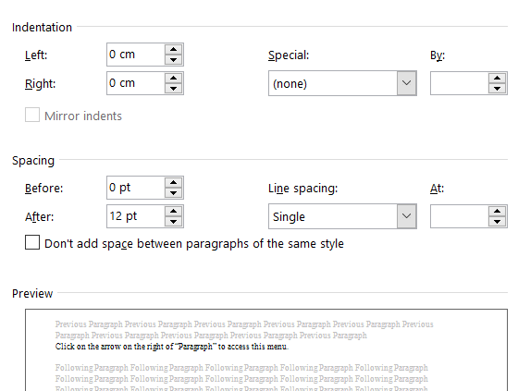

2 Changing the heights of the answer boxes.  To do this access the Table Layout menu illustrated on the right.  You can easily change the value of the Height of any box by using the up and down arrows. | 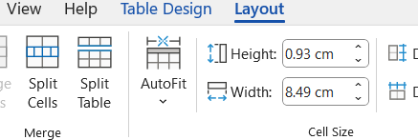
Header and copyright notice
The header in the original English version is as follows:
Schema Therapy Case Conceptualization Form
Version 3.7 Updated 29th April 2023 Page 2

This should be translated but with the addition of the following:
Schema Therapy Case Conceptualization Form
Version 3.7: Spanish translation version 1 Page 2

Of course, for “Spanish” substitute the language of your translation.


The copyright notice at the end of the documents currently reads.
© April 29th 2023. International Society of Schema Therapy
Unauthorized reproduction or translation – in whole or in part -- without written consent of the Society is strictly prohibited. Authorized translations into over 30 languages will be posted in due course on the ISST website https://schematherapysociety.org . You can also contact the ISST on this address cc@isst-schemasociety.org should you require any further information about the form, to learn if there is an authorized translation in any specific language, or to apply to make a translation into a language for which no translation has yet been made.
For the translation this should read (in the language of the translation):

© Date of translation. International Society of Schema Therapy
This is the ISST approved translation of the case conceptualization form into ___________.
The English version of which this is a translation is Version 3.7 dated April 29th 2023.
This should be followed by (In English):
© April 29th 2023. International Society of Schema Therapy
Unauthorized reproduction or translation – in whole or in part -- without written consent of the Society is strictly prohibited. Authorized translations into over 30 languages will be posted in due course on the ISST website https://schematherapysociety.org . You can also contact the ISST on this address cc@isst-schemasociety.org should you require any further information about the form, to learn if there is an authorized translation in any specific language, or to apply to make a translation into a language for which no translation has yet been made.
Ask us for help
As some of this can be a bit complex, don’t hesitate to ask us for help. Just email us at cc@isst-schemasociety.org and we will gladly assist you.

