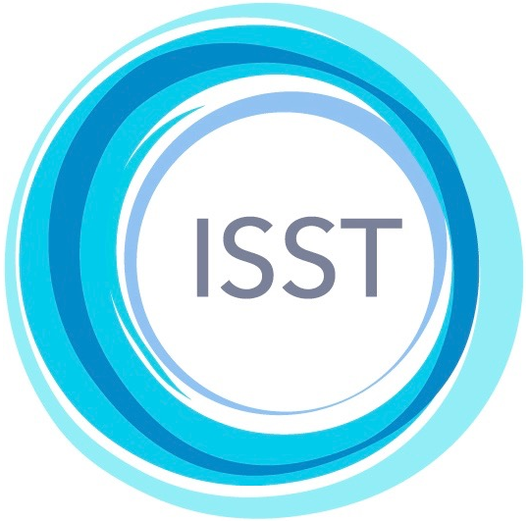 | International Society of Schema Therapy  https://schematherapysociety.org/  ISST Case Conceptualization Materials 2023  Translation Contract and Agreement  (Agreement form updated 7th May 2023)

Applicant  name | Tijana Mirović | Language of translation |  | Serbian, Bosnian, Montenegrin, Croatian
ISST Certification | Status  Trainer and supervisor | Certificate no.  613-TS |  | Date  October 20, 2016
Practice Address | Sindjeliceva 25, 11000 Belgrade, Serbia |  | Email  tijana.mirović@gmail.com

Submit this form with a copy of your ISST certification certificate to cc@isst-schemasociety.org
This agreement is between the Applicant (whose details appear above) and the ISST, represented by David Edwards, Chairperson of the Case Conceptualization Form Translation Committee. The ISST hereby invites the Applicant to translate (or arrange for the translation of) the following into the indicated language: 1) Announcement letter; 2) Case Conceptualization Form, 3) Case Conceptualization Guide, 4) Case Conceptualization Clinical Example, 5) ISST list of schema modes - Supplement to the Case Conceptualization Guide. The applicant also agrees to arrange for the translation of the Session recording background and information summary, and the STCS and STCCRS rating scales, if these have not already been translated, or if the ISST revises them.
It is understood that the Applicant:
- … is a first language speaker of the indicated language and will undertake the translations, with the assistance, if desired, of colleagues who are also first language speakers;
- … undertakes to make translations of all the documents specified above, and to supply them to the ISST;
- … may submit each of the materials to the ISST as they are completed;
- … will submit the translation of the Case Conceptualization Form within three months of the date of this agreement and the remaining materials within six months;
- … will submit the translated materials in the same format as that of the English originals, following the guidelines in the document entitled Formatting instructions for Translators;
- … will arrange for the translations to be independently checked by another first language speaker and, if there are discrepancies or disagreements, the applicant agrees to enter into discussion with the person who has done the checking in order to arrive at a mutually agreed best translation;
- … agrees that, in the event of any disputes about how particular words or phrases are to be translated, the ISST will set up a mediation process and the results of that process will determine the final translation;
- … will be acknowledged on the ISST website for his/her contribution in making the translation, but copyright of the final versions of the materials in the indicated language will be in the name of the ISST, not in the name of the Applicant.
Applicant’s signature and date | 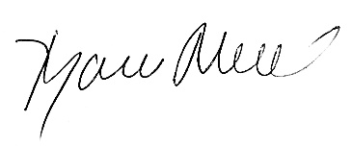  September 12th, 2023
ISST representative’s signature and date

