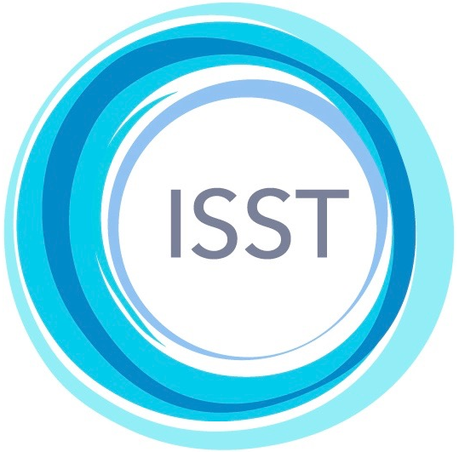  Practice and postal address | International Society of Schema Therapy  https://schematherapysociety.org/  ISST Case Conceptualization Form  Translation Contract and Agreement

Applicant  name | Tijana Mirovic | Language of translation |  | Serbian / Croatian
ISST Certification | Status  Trainer/Supervisor | Certificate no.  613-TS |  | Date  October 20, 2016
Practice Address | Schema Therapy Center Belgrade  Sinđelićeva 25  Belgrade, Serbia |  | Email  tijana.mirovic@gmail.com

The applicant must submit this form with a copy of his/her ISST certification certificate to isstccf@schematherapysouthafrica.co.za

This agreement is between the Applicant (whose details appear above) and the ISST, represented by David Edwards, President and Chairperson of the Case Conceptualization Form Translation Committee.
The ISST hereby invites the Applicant to undertake the translation into the indicated language of the Case Conceptualization Form, the Instruction Guide, the Filled-In example, and the STCCRS rating scale.
It is understood that the Applicant:
- … is a first language speaker of the indicated language and will undertake the translations, with the assistance, if desired, of colleagues who are also first language speakers;
- … may submit each of the materials to the ISST as they are completed;
- … will submit the translation of the Case Conceptualization Form within two months of the date of this agreement and the remaining materials within four months;
- … will submit the translated materials in the same format as that of the English originals;
- … will have the translations independently checked by one or more other first language speaker(s) and, if there are discrepancies or disagreements, the applicant agrees to enter into discussion with the person who has done the checking about the best translation;
- … agrees that, in the event of any disputes about how particular words or phrases are to be translated, the ISST will set up a mediation process and the results of that process will determine the final translation;
- … will be acknowledged on the ISST website for his/her contribution in making the translation, but copyright of the final versions of the materials in the indicated language will be in the name of the ISST, not in the name of the Applicant.
Applicant’s signature and date | June, 15th 2019
ISST representative’s signature and date

