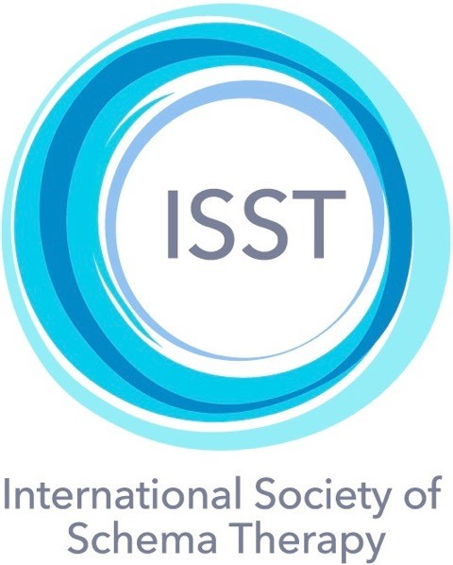

ISST CERTIFICATION AS A SCHEMA THERAPY SUPERVISOR AND A SCHEMA THERAPY TRAINER C REVISED CRITERIA AND APPLICATION PROCEDURES
Approved by the Executive Board on 7th July 2020 and effective immediately
- Entitlements of ISST certified schema therapy supervisors and trainers
  - An ISST Certified Supervisor is entitled to:
- provide supervision in schema therapy to trainees preparing to apply for ISST certification as well as to other certified schema therapists. This ISST certified supervision counts towards the supervision hours that trainees need in order to apply for certification as a schema therapist. It also counts towards ISST Continuing Education Credits.
- participate as a co-trainer (assistant to the certified trainer) in an ISST approved training program. In this case, the number of “trainers” for calculation of the trainer/participants’ ratio (1/20) includes the co-training supervisor.
  - An ISST Certified Trainer, in addition to providing ISST certified supervision (as above), is also entitled to contribute to, provide, and/or run an ISST Certified training course or Training Program.
- Application requirements for ISST certification as a supervisor or trainer
  - Applicants for certification as a Schema Therapy Supervisor must provide documented evidence of all of the following:
- having engaged in at least 2 years of Schema Therapy clinical work after the date of achieving Advanced Certification.
- having provided schema therapy to at least four clients for six months or more duration (at least 20 sessions each); of these, two must have a diagnosis of a personality disorder (or severe personality disorder traits). Adaptation of this requirement for Schema Therapy for Children and Adolescents, Schema Therapy for Couples, and Group Schema Therapy will be determined by the respective Training and Certification Committees and published in due course.
- having completed the ISST 12-hour Supervisor Skills Development workshop webinars.
- having received at least 6 hours of supervision from an ISST Certified Trainer/Supervisor on the Schema Therapy supervision they have provided to one or more ISST members who are preparing for certification as Schema Therapist(s) or to other schema therapists who are already ISST certified.
  - Applicants for certification as a Schema Therapy Trainer must include documented evidence of all of the following:
- Having spent at least one year engaged with schema therapy clinical work and supervision work from the date of achieving Certification as a Supervisor.
- having provided Schema Therapy treatment, during this one year period, to at least 2 patients of 6 months or more duration (at least 20 sessions each), of whom both must have a diagnosis of a personality disorder (or severe personality disorder traits). Adaptation of this requirement for Schema Therapy for Children and Adolescents, Schema Therapy for Couples, and Group Schema Therapy will be determined by the respective Training and Certification Committees and published in due course.
- having provided at least ten hours of supervision each to at least two candidates who are preparing to apply for ISST Certification at Standard or Advanced level.
- having served as a co-trainer in an ISST Approved training program for at least twelve hours. This includes presenting didactic material as well as supervising experiential exercises. Confirmation of this must be given in a letter of recommendation from the ISST Certified Trainer who led the program.
- Notes.
  - All the requirements and conditions set out must be from activities of the applicatant in the same certification category as that in which s/he is certified and is applying for the higher level of certification (i. e. Schema Therapy for Children and Adolescents, or Schema Therapy for Couples, or Group Schema Therapy).
  - Those certified as Advanced Schema Therapists on or before September 1, 2017, may make a single application to become a Certified Supervisor and Trainer in accordance with the previous regulations, provided that they submit a complete and correct application by 31st December 2021.

